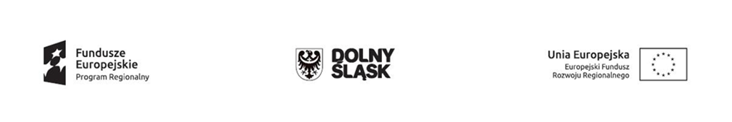
Wrocław, 18/01/2018

INFORMATION ON RESULT OF PROCEDURE

INFORMATION CONCERNING: Procurement procedure conducted in the form of a REQUEST FOR QUOTATION – COMPETITIVENESS PRINCIPLE pursuant to the 2014-2020 Guidelines on the Eligibility of Expenses within the scope of the European Regional Development Fund.

NAME OF PROGRAMME:
Regional Operational Programme for Dolnośląskie Voivodeship 2014-2020
Priority axis no. 1 "Enterprises and innovations"
Action no. 1.2 "Innovative enterprises"
Subaction no. 1.2.2 "Innovative enterprises – ZIT-WROF"
Plan no. 1.2 B "Creating and developing infrastructure of research and development of enterprises"

ORDERING PARTY
Name: Przedsiębiorstwo Produkcji Farmaceutycznej HASCO-LEK Spółka Akcyjna
Address: ul. Żmigrodzka 242 E, 51-131 Wrocław
VAT Reg. No. 8951729489 | REGON Statistical Id. No. 932249169

ANNOUNCEMENT INFORMATION
Project name: "Implementation of process innovation in Pharmaceutical Production Company Hasco-Lek S.A. in the form of computer-aided analytical and process data interpretation with the purpose of defining project space in the course of research and development activities regarding new products by way of purchasing specialist equipment and software"
This project is co-financed by the European Union through the European Regional Development Fund under the Regional Operational Programme for the Dolnośląskie Voivodeship for the years 2014-2020.
Order title: Purchase of devices for the Technological Laboratory
PURCHASE OF A LABORATORY MULTI-LAYER SINGLE-PUNCH TABLET PRESS
Order Number: 2017/HL/15
Quotation submission date:
Date: 2017-12-11 time: 09:00
Procedure status:
PROCEDURE COMPLETED

SELECTED CONTRACTOR:
NAME AND ADDRESS OF THE CONTRACTOR WITH THE MOST FAVOURABLE QUOTATION
Name: ROBERT BOSCH PACKAGING TECHNOLOGY GMBH
Address: Stuttgarter Strasse 130, 71332 Waiblingen GERMANY
Date of quotation submittal: 2017-12-10
Time of quotation submittal: 22:17
INFORMATION ON THE PRICE OF THE QUOTATION SELECTED
Net price of the quotation selected: 171 000,00
Currency: EUR
Gross price of the quotation selected: 210 330,00
Currency: EUR

COMPLETE LIST OF ENTITIES WHICH SUBMITTED QUOTATIONS AND POINTS AWARDED
Quotation no. | Contractor's name and address | Number of points in the price criterion in PLN  Weight: 80% | Number of points in the time of completion criterion  in calendar days  Weight: 10% | Number of points in the quality guarantee period criterion  in months  Weight:10% | Total points
1 | ROBERT BOSCH PACKAGING TECHNOLOGY GMBH  Stuttgarter Strasse 130, 71332 Waiblingen GERMANY | 80,00 | 10,00 | 10,00 | 100,00
2 | ROMACO KILIAN GMBH  Scarletallee 11, 50735 Koln GERMANY | Rejected | Rejected | Rejected | Rejected

Justification for rejecting the quotation submitted by ROMACO KILIAN GMBH Scarletallee 11, 50735 Koln GERMANY:
In accordance with 13.5 of the Request for Quotation (procedure no. 2017/HL/15), the Ordering Party rejects the quotation submitted by ROMACO KILIAN GMBH due to the lack of compliance of the quotation with the Request for Quotation with regard to the following:

PARAMETER REQUIRED BY THE ORDERING PARTY:
- voltage: 230 V

PARAMETER OFFERED BY THE CONTRACTOR:
- voltage: 400 V/480 V

Marcin Lankamer
……………………………….
Chairperson of the Tender
Commission

Justyna Cylkowska
……………………………….
Authorised representative of
the Ordering Party's Executive

